**Robot Radar System (Simple Distance Display)**

ANon-Syllabus Project Report

**Bachelor of Technology**

**I Year**

by

**MUKESH SINGH, PGI20CS050**

**Maruf khan, PGI20CS043**

under guidance of

**Manish Mathuriya Sir**



(Session 2020-21Even Semester)

**Poornima Group of Institute, Engineering**

ISI-6, RIICO Institutional Area, Sitapura, Jaipur – 302022

**April, 2021**

# **INTRODUCTION**

Project Doouriyan is an idea dealing with a device that can be used to measure distance digitally with the help of sonic, ultra-sonic waves without breaking any kind of sweat and the device is named as the Distanceometer.

## **OBJECTIVES**

My Project Objectives are: -

1. To able to understand the working of the Arduino
2. The working principal of optics, especially the ultrasonic waves.
3. The circuitry information (including the voltage -device compatibility)
4. To measure the distance digitally from a given point to a desired location, just like a digital measuring tape.

## **METHDOLOGY**

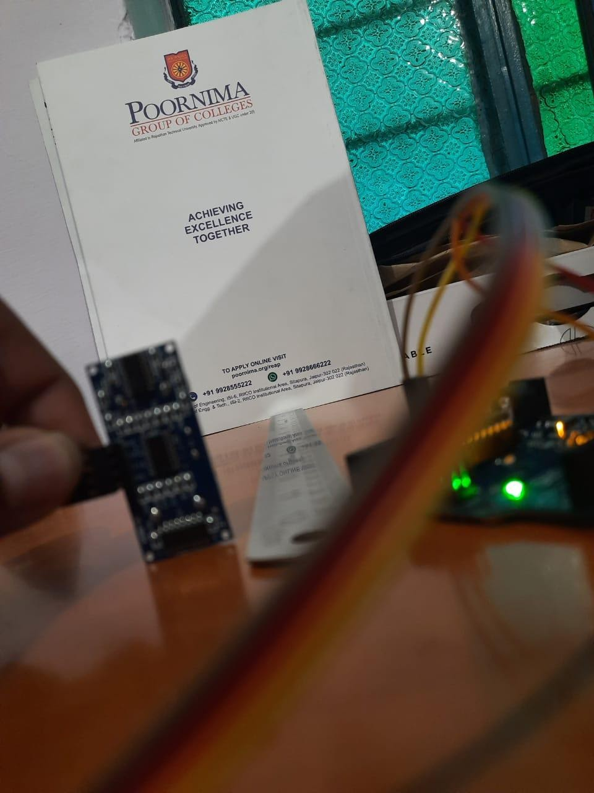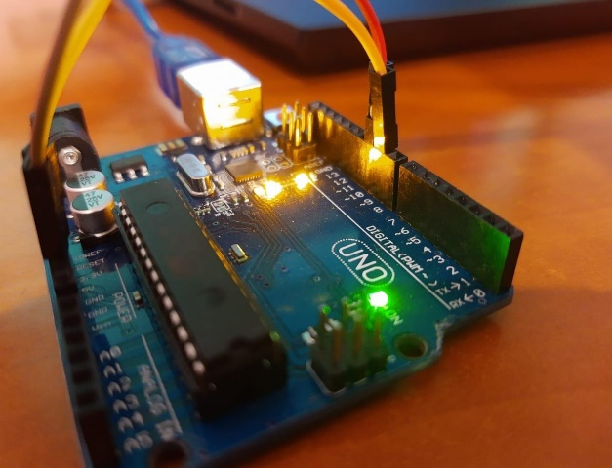Ultrasonic distance meters determine the distance to an object through the time duration, which it takes for the sound to travel to an object and back. The path length can then be calculated from the speed of the sound of the material through which the sound has passed. In the ultrasonic rangefinders, the impacting sound cannot be displayed. Some devices therefore have an additional laser display that shows the target point, but not the areas from which the sound is really reflected. Objects in the vicinity of the route or near the target point can reflect the sound and lead to incorrect measurement results. Also, for the obliquely targeted surfaces the result can be falsified. Because of the type of sound propagation, the devices are usually limited to the measuring distances of up to max. 20m. Hard material and liquids can be easily detected with the ultrasonic distance meters. Soft materials such as felt, cotton wool, foams or coarse-grained bulk goods "swallow" or scatter the sound so that they do not reflect well. At high temperatures of the measuring surface, it may lead to the deflection of the radiation, because of the heat convection of the surrounding air. Many distance warning devices in the automotive field work with the ultrasonic rangefinders/distance meters. Ultrasonic rangefinders can also be used for level monitoring. This measurement is independent of the material properties such as density and moisture of the product. The most common form of application is the measurement from above, during which the distance to the surface of the material is measured. However, there are also such sensors that detect the sound propagation directly in the medium, in single-walled containers and liquids, which enables the measurements from below or on the side of the container. With special ultrasonic rangefinders, the material thicknesses of materials – or the distance from one surface to another – can be determined. To do this, one needs to know the speed of sound specific to the material and to place the sensor directly on the object to be measured.

**HARDWARE COMPONENTS USED:**

1. **ARDUINO UNO**

It is microcontroller board developed by Arduino.cc and based on Atmega328.Electronic devices are becoming compact, flexible and cheap that are capable of doing more function as compared to their predecessors that happened to cover more space, turned out costly with the ability to perform fewer functions. Experts always strive to introduce innovation in automation that requires minimum effort and gives maximum output. Arduino Uno is a very valuable addition in the electronics that consists of USB interface, 14 digital I/O pins, 6 analog pins, and Atmega328 microcontroller. It also supports serial communication using Tx and Rx pins. You should also have a look at this UNO for beginners. There are many versions of Arduino boards introduced in the market like Arduino Uno, Arduino Due, Arduino Leonardo, Arduino Mega, however, most common versions are Arduino Uno and Arduino Mega. It is an open-source platform, means the boards and software are readily available and anyone can modify and optimize the boards for better functionality. The software used for Arduino devices is called IDE (Integrated Development Environment) which is free to use and required some basic skills to learn it. It can be programmed using C and C++ language. Some people get confused between **Microcontroller and Arduino**. While former is just an on system 40 pin chip that comes with a built-in microprocessor and later is a board that comes with the microcontroller in the base of the board, bootloader and allows easy access to input-output pins and makes uploading or burning of the program very easy.

This board comes with all the features required to run the controller and can be directly connected to the computer through USB cable that is used to transfer the code to the controller using IDE (Integrated Development Environment) software, mainly developed to program Arduino. IDE is equally compatible with Windows, MAC or Linux Systems; however, Windows is preferable to use. Programming languages like C and C++ are used in IDE.

Apart from USB, battery or AC to DC adopter can also be used to power the board.

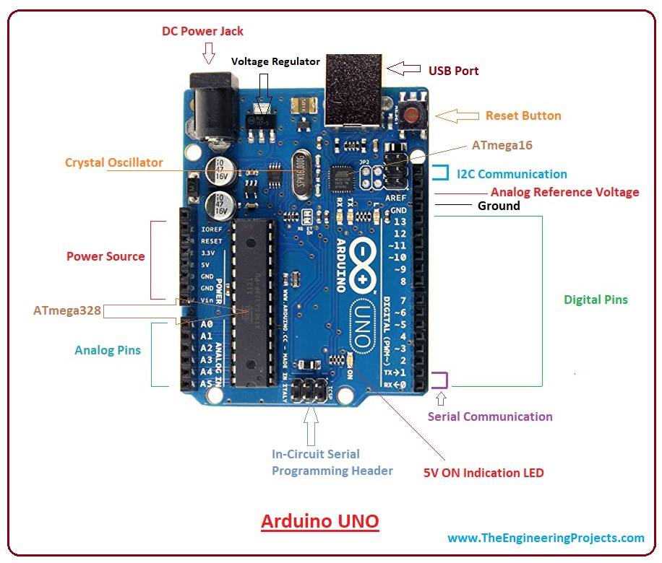Arduino Uno boards are quite similar to other boards in Arduino family in terms of use and functionality, however, Uno boards don't come with FTDI USB to Serial driver chip.

There are many versions of Uno boards available, however, Arduino Nano V3 and Arduino Uno are the most official versions that come with Atmega328 8-bit AVR Atmel microcontroller where RAM memory is 32KB.

When nature and functionality of the task go complex, Micro SD card can be added in the boards to make them store more information.

* *Features of Arduino UNO Board*
* Arduino Uno comes with USB interface i.e. USB port is added on the board to develop serial communication with the computer.
* 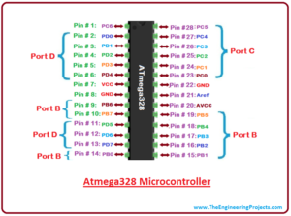Atmega328 microcontroller is placed on the board that comes with a number of features like timers, counters, interrupts, PWM, CPU, I/O pins and based on a 16MHz clock that helps in producing more frequency and number of instructions per cycle.
* It is an open source platform where anyone can modify and optimize the board based on the number of instructions and task they want to achieve.
* This board comes with a built-in regulation feature which keeps the voltage under control when the device is connected to the external device.
* Reset pin is added in the board that reset the whole board and takes the running program in the initial stage. This pin is useful when board hangs up in the middle of the running program; pushing this pin will clear everything up in the program and starts the program right from the beginning.
* There are 14 I/O digital and 6 analog pins incorporated in the board that allows the external connection with any circuit with the board. These pins provide the flexibility and ease of use to the external devices that can be connected through these pins. There is no hard and fast interface required to connect the devices to the board. Simply plug the external device into the pins of the board that are laid out on the board in the form of the header.
* The 6 analog pins are marked as A0 to A5 and come with a resolution of 10bits. These pins measure from 0 to 5V, however, they can be configured to the high range using analog Reference () function and AREF pin.
* 13KB of flash memory is used to store the number of instructions in the form of code.
* Only 5 V is required to turn the board on, which can be achieved directly using USB port or external adopter, however, it can support external power source up to 12 V which can be regulated and limit to 5 V or 3.3 V based on the requirement of the project.
* *Arduino UNO Pinout*

Arduino Uno is based on AVR microcontroller called Atmega328. This controller comes with 2KB SRAM, 32KB of flash memory, 1KB of EEPROM. Arduino Board comes with 14 digital pins and 6 analog pins. ON-chip ADC is used to sample these pins. A 16 MHz frequency crystal oscillator is equipped on the board.

* *Pin Description*

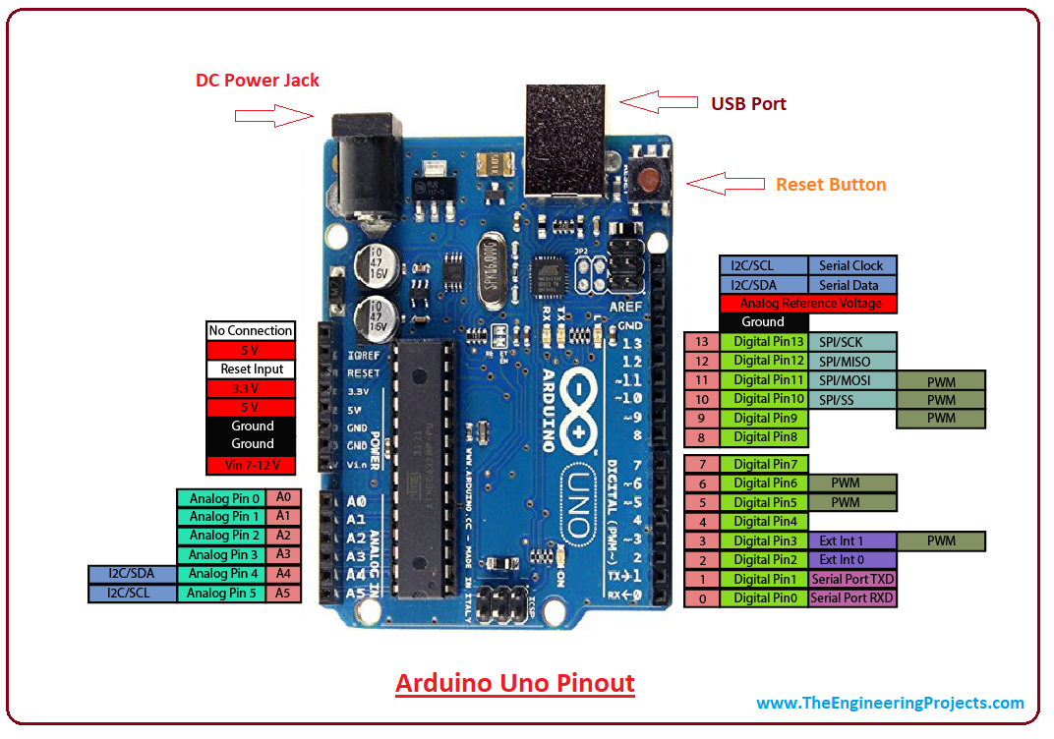There are several I/O digital and analog pins placed on the board which operates at 5V. These pins come with standard operating ratings ranging between 20mA to 40mA. Internal pull-up resistors are used in the board that limits the current exceeding from the given operating conditions. However, too much increase in current makes these resisters useless and damages the device. **LED.** Arduino Uno comes with built-in LED which is connected through pin 13. Providing HIGH value to the pin will turn it ON and LOW will turn it OFF. **Vin.** It is the input voltage provided to the Arduino Board. It is different than 5 V supplied through a USB port. This pin is used to supply voltage. If a voltage is provided through power jack. it can be accessed through this pin.**5V.** This board comes with the ability to provide voltage regulation. 5V pin is used to provide output regulated voltage. The board is powered up using three ways i.e. USB, Vin pin of the board or DC power jack. USB supports voltage around 5V while Vin and Power Jack support a voltage range between 7V to 20V. It is recommended to operate the board on 5V. It is important to note that, if a voltage is supplied through 5V or 3.3V pins, they result in bypassing the voltage regulation that can damage the board if voltage surpasses from its limit. **GND.** These are ground pins. More than one ground pins are provided on the board which can be used as per requirement **Reset.** This pin is incorporated on the board which resets the program running on the board. Instead of physical reset on the board, IDE comes with a feature of resetting the board through programming **IOREF.** This pin is very useful for providing voltage reference to the board. A shield is used to read the voltage across this pin which then select the proper power source **PWM.** PWM is provided by 3,5,6,9,10, 11pins. These pins are configured to provided 8-bit output PWM.**SPI.** It is known as Serial Peripheral Interface. Four pins 10(SS), 11(MOSI), 12(MISO), 13(SCK) provide SPI communication with the help of SPI library **AREF.** It is called Analog Reference. This pin is used for providing a reference voltage to the analog inputs **TWI.** It is called Two-wire Interface. TWI communication is accessed through Wire Library. A4 and A5 pins are used for this purpose **Serial Communication.** Serial communication is carried out through two pins called Pin 0 (Rx) and Pin 1 (Tx). Rx pin is used to receive data while Tx pin is used to transmit data **External Interrupts.** Pin 2 and 3 are used for providing external interrupts. An interrupt is called by providing LOW or changing value. **G**

* *Communications and Programming*

Arduino Uno comes with an ability of interfacing with other Arduino boards, microcontrollers and computer. The Atmega328 placed on the board provides serial communication using pins like Rx and Tx. The Atmega16U2 incorporated on the board provides a pathway for serial communication using USB com drivers. Serial monitor is provided on the IDE software which is used to send or receive text data from the board. If LEDs placed on the Rx and Tx pins will flash, they indicate the transmission of data. Arduino Uno is programmed using Arduino Software which is a cross-platform application called IDE written in Java. The AVR microcontroller Atmega328 laid out on the base comes with built-in bootloader that sets you free from using a separate burner to upload the program on the board.

* *Applications*

Arduino Uno comes with a wide range of applications. A larger number of people are using Arduino boards for developing sensors and instruments that are used in scientific research. Following are some main applications of the board.

1. **ULTRASONIC SENSOR**

The ultrasonic sensor is a transducer which converts electrical energy into sound waves and vice-versa. These sound waves fall above the normal range of human hearing and hence it is known as ultrasonic waves. These types of waves are above the frequency of about 18000 Hz. This sensor can be used as distance sensor.

* *Construction*

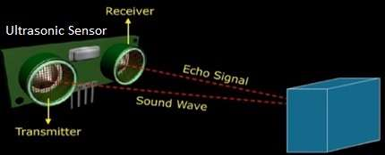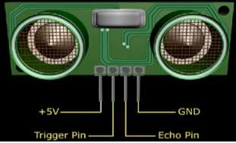There are two main parts in the ultrasonic sensor viz. transmitter and receiver.   
• The transmitter part converts electrical energy into sound and transmits it.  
• The receiver part receives the echo and turn this received sound waves into electrical energy.  
• This returned echo is measured and used for distance calculation by the ultrasonic sensor. Basically, this sensor calculates time interval between signal transmission and reception of echo and determines the distance of the object from the sensor. As this sensor is used for distance measurement it is known as **distance sensor**.

* Piezoelectric crystals are used in the ultrasonic sensor construction due to the fact that these crystals oscillate at higher range of frequencies.

Above is pin diagram of an ultrasonic sensor or distance sensor. There are four pins viz. +5V (Vcc pin), GND, Trigger pin and Echo pin.

* *Working Principle*

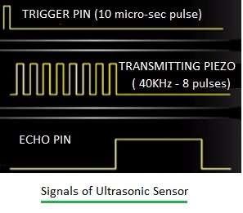Step by step working of ultrasonic sensor: -  
• STEP-1: Make 'TRIGGER' pin of sensor high for some duration (say 10µs). This will initiate sensor cycle.  
• STEP-2: Eight pulses of 40 KHz are transmitted from transmitter part of sensor. After this is done, 'ECHO' pin goes high from low state.  
• STEP-3: After the transmission, transmitted signal gets reflected from the nearby object and returns back to the sensor.  
• STEP-4: When the ultrasonic sensor detects reflected wave, 'ECHO' pin of sensor goes low.  
• STEP-5:The time duration when ECHO pin is high will provide distance between sensor and detected object.  
• STEP-6: The ultrasonic sensor is programmed in such a way that if no object is found then ECHO pin remains high for 38ms and will go low again.

### *Technical specifications of Ultrasonic Sensor*

### The typical specifications of an ultrasonic sensor are • Nominal Frequency output: 40 KHz • Coverage range: 0.2 to 6 meters • Receiver sensitivity: -67 dBm • Sound pressure level: 112 dB (minimum) • Maximum voltage input: 20 V(rms)

### *Applications*

### *• It is used in automatic car parking system. • It is used in humanoid robot design.*

1. **LCD 16x2**

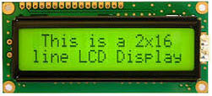The term [LCD stands for liquid crystal display](https://www.elprocus.com/difference-alphanumeric-display-and-customized-lcd/). It is one kind of electronic display module used in an extensive range of applications like various circuits & devices like mobile phones, calculators, computers, TV sets, etc. These displays are mainly preferred for multi-segment [light-emitting diodes](https://www.elprocus.com/light-emitting-diode-led-working-application/) and seven segments. The main benefits of using this module are inexpensive; simply programmable, animations, and there are no limitations for displaying custom characters, special and even animations, etc. This uses the property of light monitoring of liquid crystal and they do not emit the light directly. The Liquid crystal display is a flat panel display or the electronic visual display. With low information, content the LCD’ s are obtained in the fixed image or the arbitrary image which are displayed or hidden like present words, digits, or [7 segment display](https://www.elprocus.com/types-of-7-segment-displays-and-controlling-ways/). The arbitrary images are made up of large no of small pixels and the element has larger elements.

* *Pin Connections & uses*

|  |  |  |
| --- | --- | --- |
| **Pin No.** | **Pin Name** | **Pin Description** |
| Pin 1 | GND | This pin is a ground pin and the LCD is connected to the Ground |
| Pin 2 | VCC | The VCC pin is used to supply the power to the LCD |
| Pin 3 | VEE | This pin is used for adjusting the contrast of the LCD by connecting the variable resistor in between the VCC & Ground. |
| Pin 4 | RS | The RS is known as register select and it selects the Command/Data register. To select the command, register the RS should be equal to zero. To select the Data register the RS should be equal to one. |
| Pin 5 | R/W | This pin is used to select the operations of Read/Write. To perform the write operations the R/W should be equal to zero. To perform the read operations the R/W should be equal to one. |
| Pin 6 | EN | This is a enable signal pin if the positive pulses are passing through a pin, then the pin function as a read/write pin. |
| Pin 7 | DB0 to DB7 | The pin 7 contains total 8 pins which are used as a Data pin of LCD. |
| Pin 15 | LED + | This pin is connected to VCC and it is used for the pin 16 to set up the glow of backlight of LCD. |
| Pin 16 | LED – | This pin is connected to Ground and it is used for the pin 15 to set up the glow of backlight of the LCD |

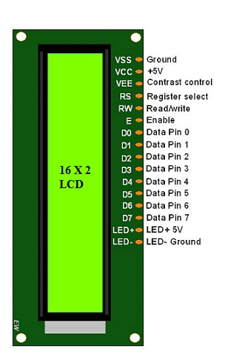

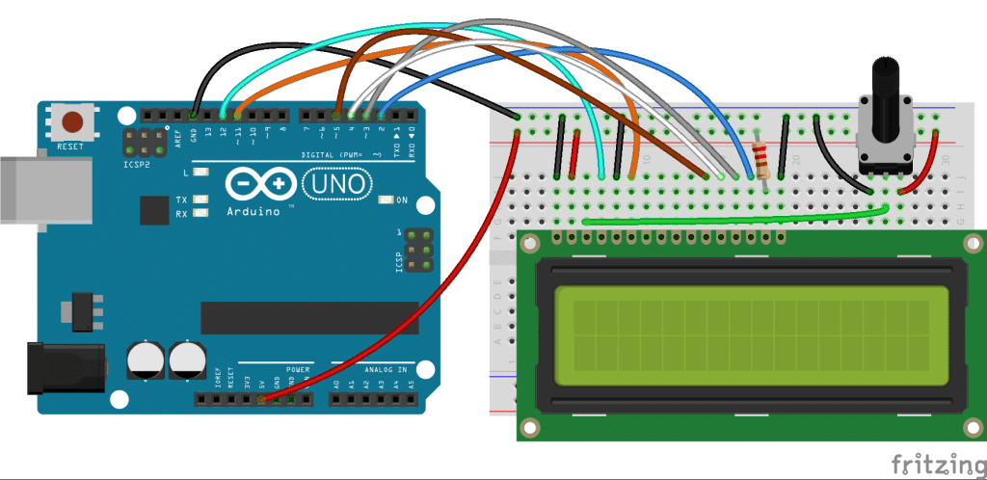

* *Registers of LCD*

A 16×2 LCD has two [registers](https://www.elprocus.com/know-about-types-of-registers-in-8051-microcontroller/) like data register and command register. The RS (register select) is mainly used to change from one register to another. When the register set is ‘0’, then it is known as command register. Similarly, when the register set is ‘1’, then it is known as data register.

* *Command Register*

The main function of the command register is to store the instructions of command which are given to the display. So that predefined tasks can be performed such as clearing the display, initializing, set the cursor place, and display control. Here commands processing can occur within the register.

* *Data Register*

The main function of the data register is to store the information which is to be exhibited on the LCD screen. Here, the ASCII value of the character is the information which is to be exhibited on the screen of LCD. Whenever we send the information to LCD, it transmits to the data register, and then the process will be starting there. When register set =1, then the data register will be selected.

* *Role of LCD in an Arduino system*

In Arduino based embedded system design, the Liquid Crystal Display modules play a very important role. Hence it is very important to learn about [how to interface LCD](https://www.elprocus.com/lcd-interfacing-with-8051-microcontroller/) with an Arduino of 16×2 in embedded system design. The display units are very important in communication between the human world and the machine world. The display unit work on the same principle, it does not depend on the size of the display it may be big or the small. We are working with the simple displays like 16×1 and 16×2 units. The 16×1 display unit has the 16 characters which present in one line and 16×2 display units have 32 characters which are present in the 2 line. We should know that to display each character there are 5×10 pixels. Thus to display one character all the 50 pixels should be together. In the display, there is a controller which is HD44780 it is used to control the pixels of characters to display.

* 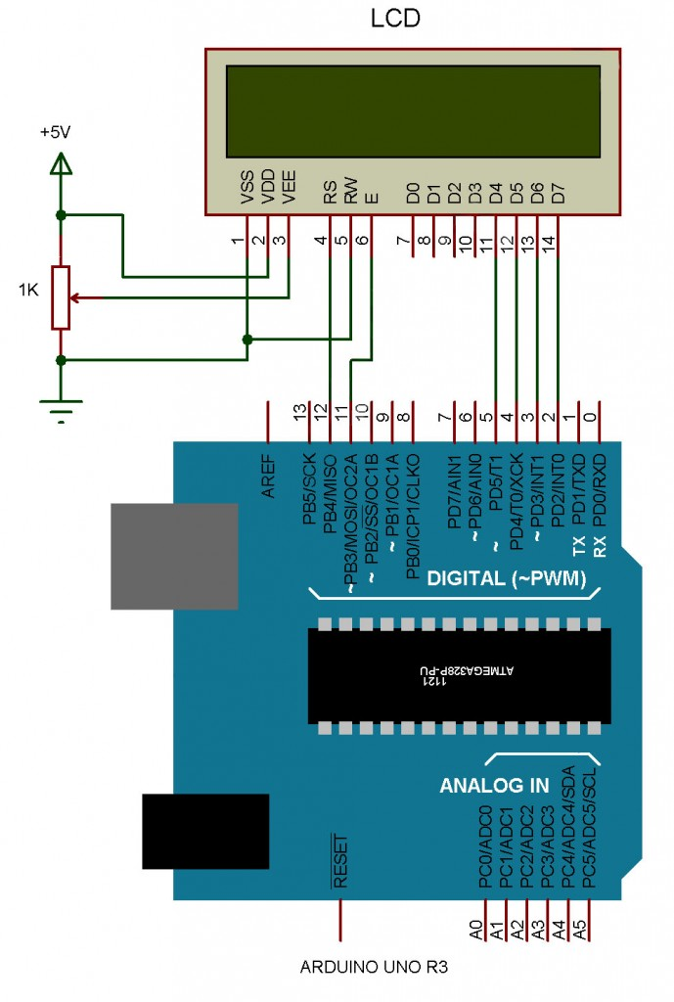*LCD Interfacing with the Arduino Module*

The following circuit diagram shows the liquid crystal display with the [Arduino module](https://www.elprocus.com/arduino-basics-and-design/). From the circuit diagram, we can observe that the RS pin of the LCD is connected to the pin 12 of the Arduino. The LCD of R/W pin is connected to the ground. The pin 11 of the Arduino is connected to the enable signal pin of LCD module. The LCD module & Arduino module are interfaced with the 4-bit mode in this project. Hence there are four input lines which are DB4 to DB7 of the LCD. This process very simple, it requires fewer connection cables and also, we can utilize the most potential of the LCD module. The digital input lines (DB4-DB7) are interfaced with the Arduino pins from 5-2. To adjust the contrast of the display here we are using a 10K 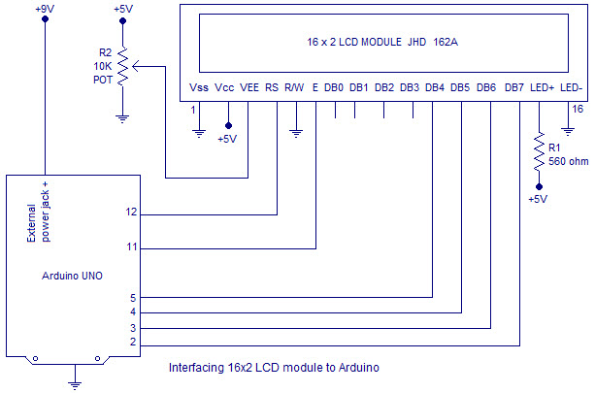potentiometer. The current through the back LED light is from the 560-ohm resistor. The external power jack is provided by the board to the Arduino. Using the PC through the USB port the Arduino can power. Some parts of the circuit can require the +5V power supply it is taken from the 5V source on the Arduino board.

* *Features of LCD16x2*

The features of this LCD mainly include the following: -

* The operating voltage of this LCD is 4.7V-5.3V
* It includes two rows where each row can produce 16-characters.
* The utilization of current is 1mA with no backlight
* Every character can be built with a 5×8-pixel box
* The alphanumeric LCDs alphabets & numbers
* Is display can work on two modes like 4-bit & 8-bit
* These are obtainable in Blue & Green Backlight
* It displays a few custom generated characters
* *Conclusion*

Thus, this is all about LCD 16×2 datasheet, which includes what is a 16X2 LCD, pin configuration, working principle, and its applications. The main advantages of this LCD device include power consumption is less and low cost. The main disadvantages of this LCD device include it occupies a large area, slow devices and also lifespan of these devices will be reduced due to direct current. So these LCDs use AC supply with less than 500Hz frequency.

1. **SERVO MOTOR**

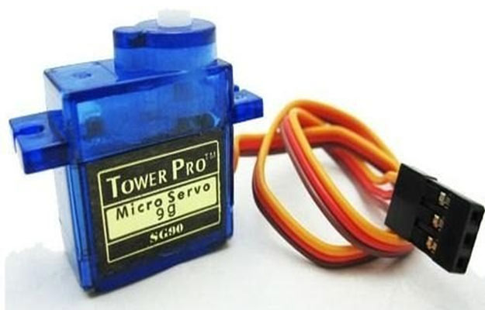Servo is an electromagnetic device uses a negative feedback mechanism to converts an electric signal into controlled motion. Basically, servos behave like as actuators which provide precise control over velocity, acceleration, and linear or angular position. It consists of four things: DC motor, position sensor, gear train, and a control circuit. The gear mechanism connected with the motor provides the feedback to the position sensor. The**servo motor** is most commonly used for high technology devices in the industrial application like automation technology. It is a self-contained electrical device, that rotate parts of a machine with high efficiency and great precision. The output shaft of this motor can be moved to a particular angle. Servo motors are mainly used in home electronics, toys, cars, airplanes, etc.

Servo motors being manufactured by many companies some of them are FUTABA, HITECH, AIRTRONICS, and JR RADIOS. They are the same in manufacturing but different in connector type, wire colors, etc. There are numbers of types of servos are available in the market, AC, DC, continuous, positional and linear servo motor

* *Types of Servo Motor*

Servo motors are classified into different types based on their application, such as AC servo motor, DC servo motor, brushless DC servo motor, positional rotation, continuous rotation and linear servo motor etc. Typical servo motors comprise of three wires namely, power control and ground. The shape and size of these motors depend on their applications. RC servo motor is the most common type of servo motor used in hobby applications, robotics due to their simplicity, affordability and reliability of control by microprocessors.

*1) DC Servo Motor*

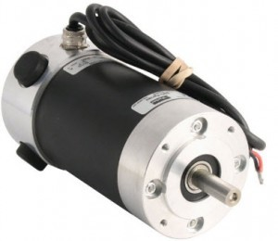The motor which is used as a DC servo motor generally have a separate DC source in the field of winding & armature winding. The control can be archived either by controlling the armature current or field current. Field control includes some particular advantages over armature control. In the same way armature control includes some advantages over field control. Based on the applications the control should be applied to the DC servo motor. DC servo motor provides very accurate and also fast respond to start or stop command signals due to the low armature inductive reactance. DC servo motors are used in similar equipments and computerized numerically controlled machines.

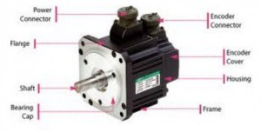*2) AC Servo Motor*

AC servo motor is an AC motor that includes encoder is used with controllers for giving closed loop control and feedback. This motor can be placed to high accuracy and also controlled precisely as compulsory for the applications. Frequently these motors have higher designs of tolerance or better bearings and some simple designs also use higher voltages in order to accomplish greater torque. Applications of an AC motor mainly involve in automation, robotics, CNC machinery, and other applications a high level of precision and needful versatility.

***3****) Positional Rotation Servo Motor*

Positional rotation servo motor is a most common type of servo motor. The shaft’s o/p rotates in about 180o. It includes physical stops located in the gear mechanism to stop turning outside these limits to guard the rotation sensor. These common servos involve in radio-controlled water, radio-controlled cars, aircraft, robots, toys and many other applications.

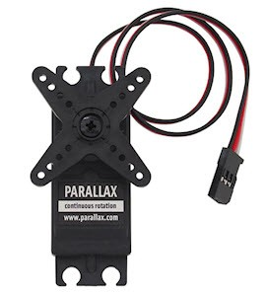

*4) Continuous Rotation Servo Motor*

Continuous rotation servo motor is quite related to the common positional rotation servo motor, but it can go in any direction indefinitely. The control signal, rather than set the static position of the servo, is understood as the speed and direction of rotation. The range of potential commands sources the servo to rotate clockwise or anticlockwise as preferred, at changing speed, depending on the command signal. This type of motor is used in a radar dish if you are riding one on a robot or you can use one as a drive motor on a mobile robot

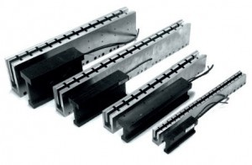*5) Linear Servo Motor*

Linear servo motor is also similar the positional rotation servo motor is discussed above, but with an extra gear to alter the o/p from circular to back-and-forth. These servo motors are not simple to find, but sometimes you can find them at hobby stores where they are used as actuators in higher model airplanes.

* *Construction of Servo Motor*

The Servo motor is DC motor which has 5 following parts: -

* 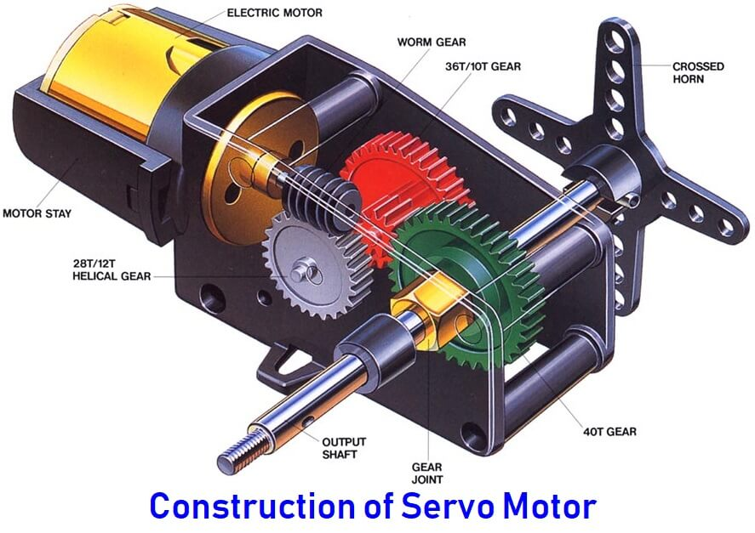*Stator Winding*: This type of winding wound on the stationary part of the motor. It is also known as field winding of the motor.
* *Rotor Winding*: This type of winding wound on the rotating part of the motor. It is also known as an armature winding of the motor.
* *Bearing****:*** These are of two types, i.e., font bearing and back bearing which are used for the movement of the shaft.
* *Shaft:* The armature winding is coupled on the iron rod is known as the shaft of the motor.
* *Encoder:* It has the approximate sensor which determines the rotational speed of motor and revolution per minute of the motor.
* 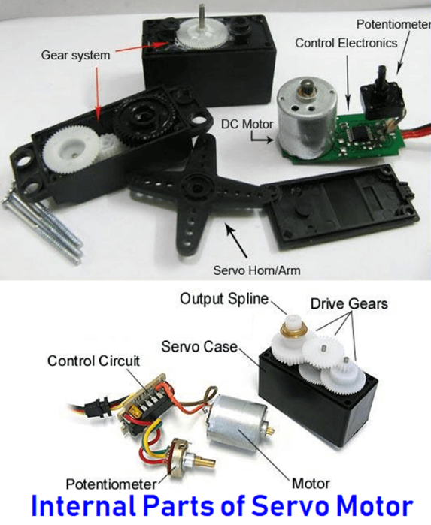*Servo Motor Working*

It consists of three basic types:

* Controlling Device
* Output Sensor
* Feedback system

The servo motor works on the phenomenon of the automatic closed-loop system. The controller is required for this closed-loop system. This controller is composed of a comparator and a feedback path. It has one output and two inputs. In this, for producing an output signal, the comparator is used to compare the required reference signal and this output signal is sensed by the sensor. The input signal for the motor is termed as a feedback signal. On the basis of the feedback signal, the motor starts 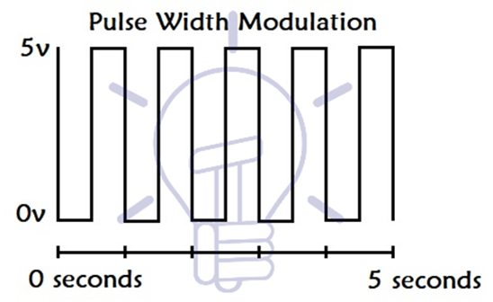working. Comparator signal is called a logic signal of the motor. The motor would be ON for the desired time when the logical difference is higher and the motor would be OFF for the desired time when the logical difference is lower. Basically, a comparator is used to decide that motor would be ON or OFF. Proper functioning of the motor can be done with the help of a good controller.

* *Controlling of Servo Motor****:***

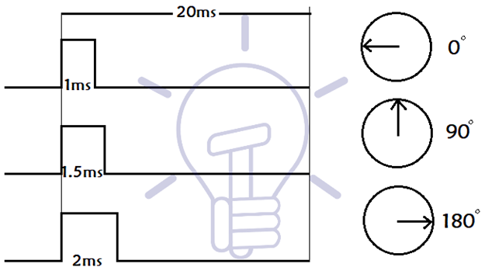The servo motors can be controlled by the method PWM i.e., Pulse Width Modulation. These send electric signals of inconsistent width to the motor. The width pulse is varied in the range of 1 millisecond to 2 milliseconds and transfer this to the servo motors with repeating 50 times in a second. The width of the pulse controls the angular position of the rotating shaft. In this, three terms are used which shows the controlling of the servomotor i.e., a maximum pulse, minimum pulse and repetition rate.

* **For example**, the servo moves with the pulse of 1 millisecond to turn motor towards 0˚ whereas a pulse of 2 milliseconds to turn motor towards 180˚ Between the angular positions, the pulse width interchange by itself. Therefore, the servo turns to the 90˚ with the pulse of width 1.5 milliseconds.

There are three wires or leads in every servo motor. The two wires used from positive supply and ground supply whereas the third wire is used to control the signal.

* 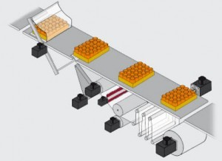*Applications of Servo Motor:*
* They play an important role in robotics information of robot because of their smooth switching on or off and accurate positioning.
* They are used to maintain the speed of vehicles in the automobile industries.
* The servo motor is used in robotics to activate movements, giving the arm to its precise angle.
* The Servo motor is used to start, move and stop conveyor belts carrying the product along with many stages. For instance, product labeling, bottling and packaging
* The servo motor is built into the camera to correct a lens of the camera to improve out of focus images.
* The servo motor is used in robotic vehicle to control the robot wheels, producing plenty torque to move, start and stop the vehicle and control its speed.
* The servo motor is used in solar tracking system to correct the angle of the panel so that each solar panel stays to face the sun
* The Servo motor is used in metal forming and cutting machines to provide specific motion control for milling machines
* The Servo motor is used in Textiles to control spinning and weaving machines, knitting machines and looms
* The Servo motor is used in automatic door openers to control the door in public places like supermarkets, hospitals and theatres

**EXPERIMENTAL RESULTS /CODING /ALGORITHM (WITH SCREENSHOTS)**

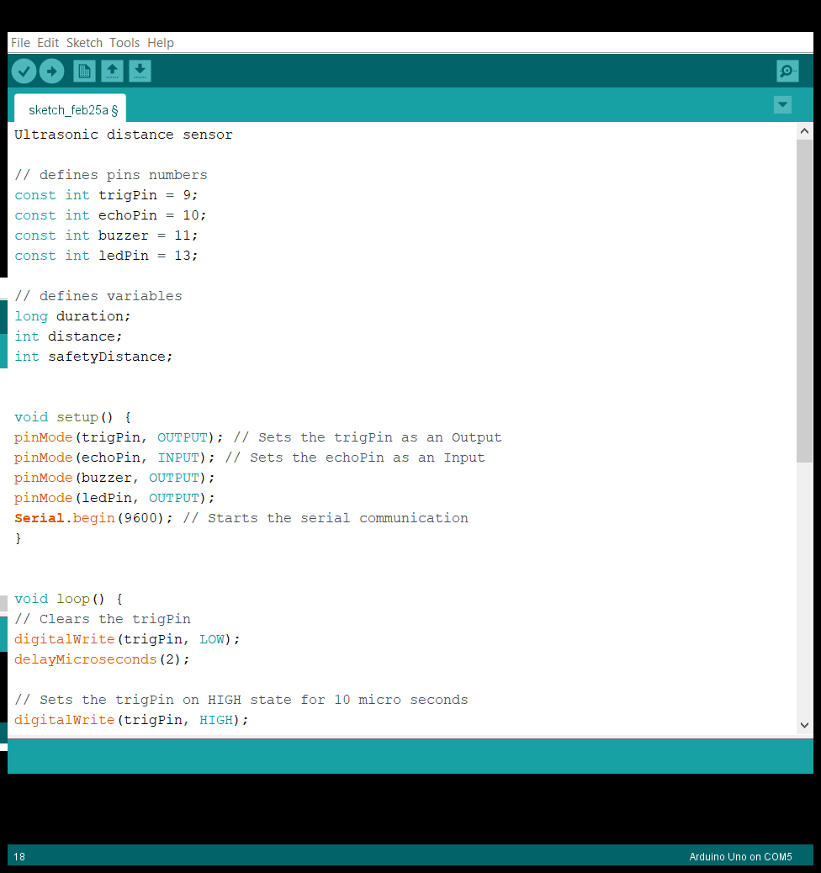Ultrasonic distance sensor with buzzer

// defines pins numbers

const int trig Pin = 9;

const int echoPin = 10;

const int buzzer = 11;

const int ledPin = 13;

// defines variables

long duration;

int distance;

int safetyDistance;

void setup() {

pinMode (trigPin, OUTPUT); // Sets the trigPin as an Output

pinMode (echo Pin, INPUT); // Sets the echo Pin as an Input

pinMode (buzzer, OUTPUT);

pinMode (led Pin, OUTPUT);

Serial. Begin (9600); // Starts the serial communication

}

void loop () {

// Clears the trigPin

digital Write (trigPin, LOW);

delay Microseconds (2);

// Sets the trigPin on HIGH state for 10 micro seconds

digital Write (trigPin, HIGH);

delayMicroseconds(10);

digitalWrite(trigPin, LOW);

// Reads the echoPin, returns the sound wave travel time in microseconds

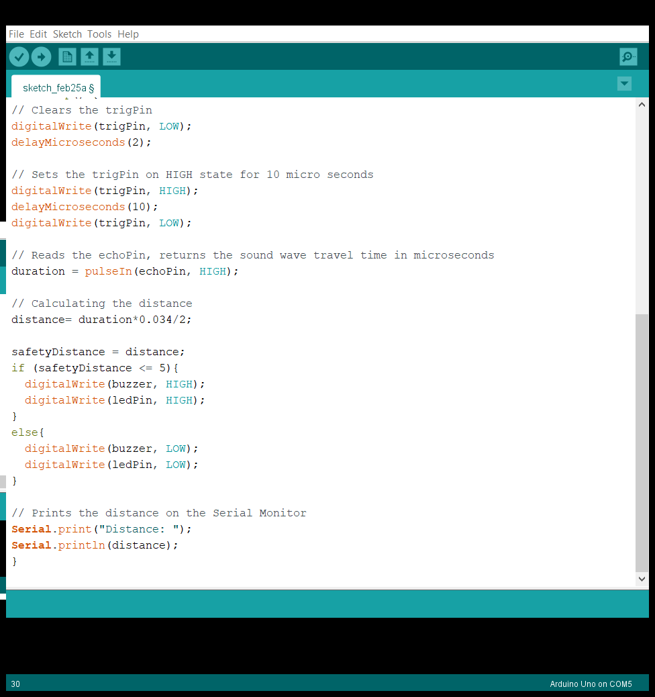duration = pulse in (echoPin, HIGH);

// Calculating the distance

distance= duration*0.034/2;

safety Distance = distance;

if (safety Distance <= 5) {

digitalWrite(buzzer, HIGH);

digitalWrite (led Pin, HIGH);

}

else {

digitalWrite (buzzer, LOW);

digitalWrite (led Pin, LOW);

}

// Prints the distance on the Serial Monitor

Serial. Print ("Distance: ");

Serial.println(distance);

}

**FUTURE WORK**

* Robotic sensing
* Stacking height control
* Loop control
* Liquid level control
* Full detection
* Counting people/people detection
* Detecting breaks in threads or wires
* Contouring or profiling
* Irregular parts detection
* Tank level detection
* Many applications on the production line
* Distance measurement - regardless of an object's shape, colour or surface texture
* Loop control
* Roll diameter, tension control, winding and unwind
* Thru beam detection for high-speed counting
* Thread or wire break detection
* Robotic sensing
* Stacking height control
* 45° Deflection; inkwell level detection; hard to get at places
* People detection for counting
* Contouring or profiling using ultrasonic systems
* Vehicle detection for car wash and automotive assembly
* Irregular parts detection for hoppers and feeder bowls
* Presence detection
* Box sorting using multi-transducer ultrasonic monitoring system

**CONCLUSION**

A basic functioning digital inch tape with lots of future applications if used wisely /smartly.

**REFERENCE**

* Nawal, Meenakshi, and G. N. Purohit. "ECG based human authentication: a review." *Int. J. Emerg. Eng. Res. Technol* 2.3 (2014): 178-185.
* Intelligent aspiring, great minds of Poornima College of Engineering.